L3 Report

Name: Ankita Singh

Intern ID: XS/IN/0792

# Certification:

I have completed my Microsoft Certified: Azure Administrator Associate Link: <https://learn.microsoft.com/api/credentials/share/en-us/AnkitaSingh-0120/8958557184A82266?sharingId=2F4D2A9C7DF7F754>

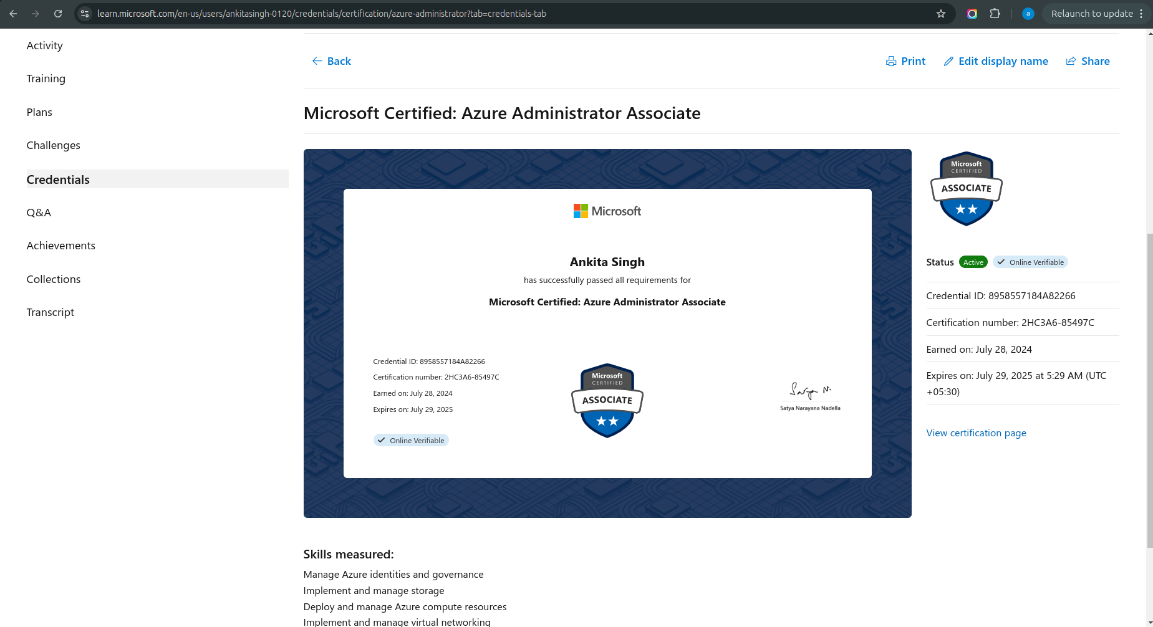

# Projects & Solutions:

## 1) Amdocs

I worked on various tasks related to data management and cloud infrastructure, specifically for Amdocs projects, focusing on updating and organizing data for Cloud Grazer and AWS. The contributions I made are:

1. Reviewed and updated the leftover data sheet with instance IDs, Defender versions, and cluster names for data accuracy.
2. Created a new spreadsheet to address lookup use cases, ensuring a well-organized data structure.
3. Updated the Wireless 5G-Needs Defender sheet to reflect accurate account and region assignments, ensuring the JSON file was in sync.
4. Verified leftover IPs with Cloud Grazer, and documented account IDs for IPs available in Cloud Grazer but marked as N/A in the sheet.
5. Collaborated on the Wireless 5G_Needs Defender and Subnet_reqd sheets to extract subnet and CIDR information from Cloud Grazer.
6. Ran eni_details and SSO scripts to update IP information for two accounts, merging the data into the main sheet and verifying cluster names and node statuses by logging into clusters.
7. Developed a Boto3 script to fetch user details from Cloud9 and EKS based on their account IDs for improved user management and data tracking.

## 2) Akira ai--(Backend Resources)

1. Worked on user and customer onboarding flow as a backend resource, ensuring smooth integration of APIs.
2. Created an API to handle customer details, enabling efficient data management.
3. Developed a Swagger file to document and define all APIs for better clarity and usage.
4. Collaborated with the front-end team to integrate the APIs, ensuring seamless end-to-end functionality.

## 3) Gen ai project Management--(Backend Resources)

1. Worked as a backend resource on Login and Signup functionalities, ensuring smooth user authentication.
2. Developed APIs for the Dashboard page, including admin progress, daily task log, daily timesheet log, and weekly/monthly timesheet log pages.
3. Contributed to the development of the homepage and user landing page as a backend resource.
4. Created and integrated APIs for the homepage and user landing page to ensure seamless user interaction and data flow.

## 4) RPA Training

1. Worked on Robotic Process Automation (RPA) tools, focusing on the fundamentals of RPA.
2. Involved in process identification, design, and implementation to create efficient RPA solutions.
3. Managed and optimized RPA processes to improve performance and effectiveness.
4. Created multiple workflows as per requirements, ensuring seamless automation in various processes.

## 5) Akira ai Testing

1. Created comprehensive test case documentation for the entire website, covering all functionalities and scenarios.
2. Developed detailed bug reports to identify, track, and resolve issues effectively during testing.

## 6) Xenonstack Product Testing

1. Worked on the Coverage-Drilldown-2024-09-27 sheet, ensuring accurate data and updates.
2. Managed the Xenonstack website redirect link available on the sheet for proper functionality.

## 7) TYP

1. Worked on the WhatsApp SMS delivery section for different scenarios (with booking, without booking, and booking + pin notification), ensuring proper functionality.
2. Conducted end-to-end (E2E) testing for the WhatsApp SMS delivery section to verify its effectiveness.
3. Worked on staging E2E testing to identify bugs at the failed transport orders (TO) stage at development and documented the findings.
4. Tested the transport orders page to identify bugs and created a detailed documentation of the issues found, including warehouse storage scenarios such as new delivery attempts, recipient collection at the branch, return to sender, at the pulp, and delivery address change.

## 8) Xenonstack website

1. Conducted end-to-end (E2E) testing for the entire Xenonstack website, covering all pages and header components, including the Progressive Delivery section with its 6 subpages.
2. Developed E2E test cases for the Xenonstack navigation bar, focusing on sections like Data and AI factory, Accelerator, Industries, Neutral AI, and Company pages to support automation.
3. Worked on copying the URLs of each page to the performance report script and utilized Lighthouse scripts to crawl and fetch performance insights, ensuring correct URL redirects.
4. Created E2E test cases for the Xenonstack homepage footer section and ensured automation support for each page's performance.
5. Worked on the XS-Migration-Oct-2024 sheet, handling new Xenonstack homepage URL redirects, ensuring proper link mapping, and updating titles, descriptions, and H1 tags from the previous site.
6. Contributed to multiple blogs on Embedded Software Testing, Test Automation for Legacy Systems, and Data Privacy Testing while also working on Core Web Vitals and speed testing sheets for both the Xenonstack website and its blogs.

## 9) ALP (Automated Landing platform)

1. Prepared a prerequisite document for testing the application, detailing the timeline, tools used, and required inputs from data, frontend, and backend teams to ensure effective testing from the client-side perspective.
2. Created manual test cases based on the Figma designs for the customer and broker end flows, ensuring thorough testing of all user interactions.
3. Developed a vulnerability testing document outlining the prerequisites, tools, and permissions required for testing the application, focusing on data and IT operations security for sensitive documents.
4. Ensured that all necessary approvals, tools, and access were in place for proper vulnerability testing, addressing potential security risks in the application.

## 10) Xenonstack AI (Currently working)

1. Conducted testing at two levels (Staging and Deployment) for the Daily Production Page, ensuring that each page (e.g., Main Page, Solution Page, Internal Solution Page, Use Cases Page, Book Demo Page, Get Started Page) was thoroughly tested for functionality and performance.
2. Used Cypress tools for automation testing at both stages (Staging and Deployment) to ensure consistent and accurate testing for each page's features and user flows.
3. Identified and documented bugs for each page based on test results from both staging and deployment environments, highlighting issues such as broken links, incorrect redirects, or functional discrepancies.
4. Provided detailed reports on the identified bugs for each page, including reproduction steps, severity, and suggested fixes, ensuring seamless integration and user experience at the deployment stage.

## 11) Agents and Agentic templates (Currently working)

1. Managed daily blog template posting based on the "Ready to Publish" status using an Excel sheet.
2. Updated and tracked blog posts in the Excel sheet to ensure timely posting and publishing.

# Experimental Saturdays

Task 1: okta authentication with React application.

1. 1. Integrated Okta authentication with React application.
2. Designed architecture with React and Okta.
3. Configured Okta settings and group claims.
4. Installed necessary packages for Okta integration.
5. Implemented role-based access and authentication flow.
6. Overcame challenges in Okta SDK connection.

Created document on it. Research Report: [okta authentication.docx](https://xenonstack1-my.sharepoint.com/:w:/r/personal/ankita_singh_xenonstack_com/Documents/okta%20authentication.docx?d=wa035398cb5a74f02bd1efbe19059552e&csf=1&web=1&e=cLqKWQ)

Recording Link: <https://xenonstack1-my.sharepoint.com/:v:/g/personal/ankita_singh_xenonstack_com/EdvxqUgyEdZGhNDCn4DzuKgBx9QYSwHNtD6-b5nU-mJowA?e=4TP5rr>

PPT: <https://xenonstack1-my.sharepoint.com/:p:/r/personal/ankita_singh_xenonstack_com/Documents/Microsoft%20Teams%20Chat%20Files/Introduction-to-Okta-Authentication%201.pptx?d=w9ef3c8c2bcbf41029a28c74156d1e945&csf=1&web=1&e=h6Jx2e>

Task 2: GIthub Action Bot

1. Setting Up an Account for Your Bot
2. Configuring the Bot to Listen for Pull Requests
3. Writing the Code for the Bot
4. Deploying and Testing Your Bot

Research Report: Documents- <https://xenonstack1-my.sharepoint.com/:w:/r/personal/ankita_singh_xenonstack_com/Documents/GitHub%20action%20Chatbot.docx?d=w6a45da5b2d7743eb88e2f711b0e69a95&csf=1&web=1&e=T9TviS>

PPT: <https://xenonstack1-my.sharepoint.com/:p:/g/personal/ankita_singh_xenonstack_com/Ea-TLAGeDuNDk8lnAfOnsXkBjB4p24BaaLaZcnU75TC_UA?e=p4ofwh>

Recording Link: [Recording Link](https://xenonstack1-my.sharepoint.com/:v:/r/personal/jatin_sharma_xenonstack_com/Documents/Recordings/Technical%20Session%20_%20Three.js%20for%203D%20Design%20_%20Shail-20240806_160459-Meeting%20Recording.mp4?csf=1&web=1&e=nad5SI&nav=eyJyZWZlcnJhbEluZm8iOnsicmVmZXJyYWxBcHAiOiJTdHJlYW1XZWJBcHAiLCJyZWZlcnJhbFZpZXciOiJTaGFyZURpYWxvZy1MaW5rIiwicmVmZXJyYWxBcHBQbGF0Zm9ybSI6IldlYiIsInJlZmVycmFsTW9kZSI6InZpZXcifX0%3D)

Tasks 3: work on Agentic RAG with Lama3.1

1. work on Research as well as implementation part and Documentation
2. Understanding RAG and Agentic RAG
3. Agentic RAG
4. Implementation with Lama3.1 of RAG and Agentic RAG locally
5. Comparison of RAG and Agentic RAG

Documents report: [Agentic RAG with Lama3.docx](https://xenonstack1-my.sharepoint.com/:w:/r/personal/ankita_singh_xenonstack_com/Documents/Agentic%20RAG%20with%20Lama3.docx?d=w76d86bee8591405bbcfb1e5f745e08d7&csf=1&web=1&e=jGwRwQ)